**PLM LIBRARY INVENTORY SYSTEM**

(a console-based application)

THE WHOLE PROJECT INVOLVES 3 C++ FILES AND A .DAT FILE FOR STORING THE BOOK DETAILS.  
The C++ version used is **C++20**

**Main.cpp**

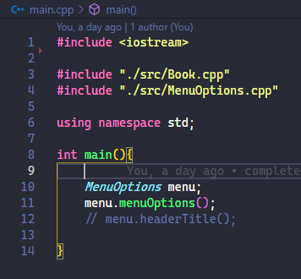

The main file imports iostream and 2 other files which are Book.cpp and MenuOption.cpp

**Book.cpp**

Book.cpp is a file that contains the Book class so that I can create an object and read it more efficiently since there are variables created specifically to bookName, authorName, isbn, genre and quantity

I decided to use string as data type for ISBN because ISBN may consist of alphanumeric characters.

I use struct instead of class because I wanted to make my object to be public by default instead of using class and make it as public.

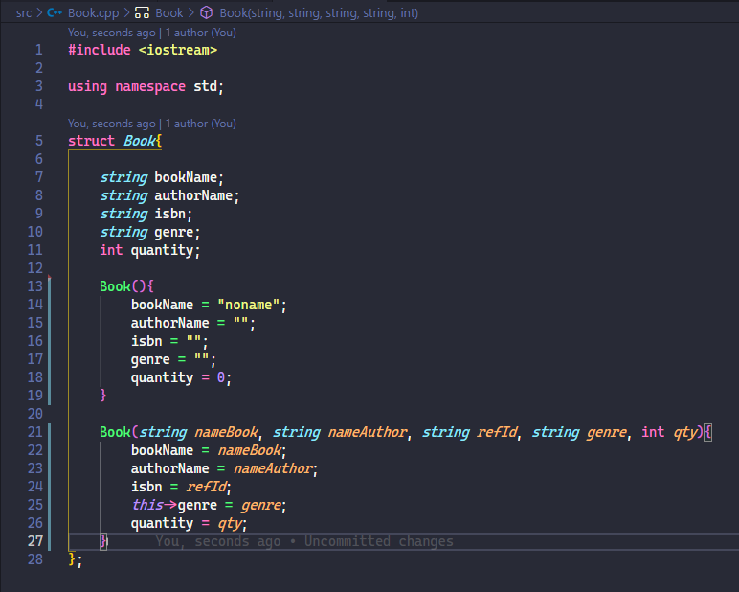

I decided to create 2 constructor function for my Book class the first one is to create an empty book and the second one is to create a user-defined Book consisting of the title, author, ISBN, genre or category and the number of books.

**MenuOptions.cpp**

This part can be done without the use of class, however, I wanted to avoid getting “out of scope” error because functions needs to be place above of the call statement. As a solution, I use class so that order of functions will not be prioritized, it means that, I can call any function with ease and without worrying of getting an error.

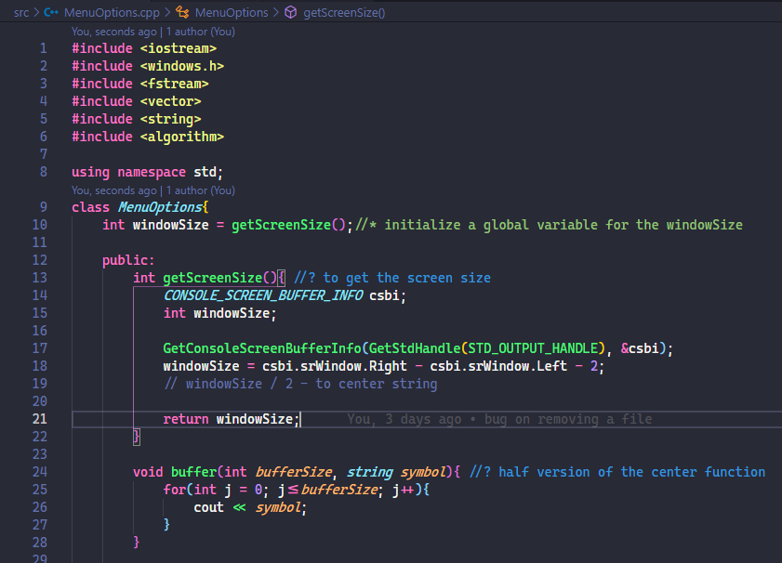

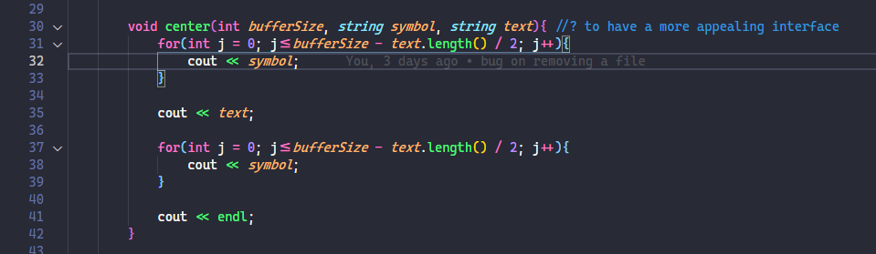

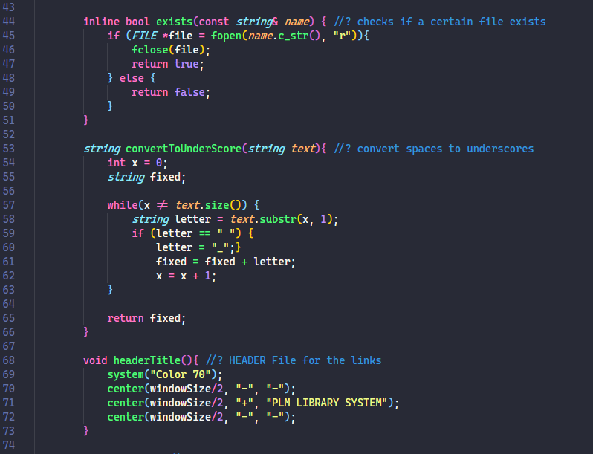

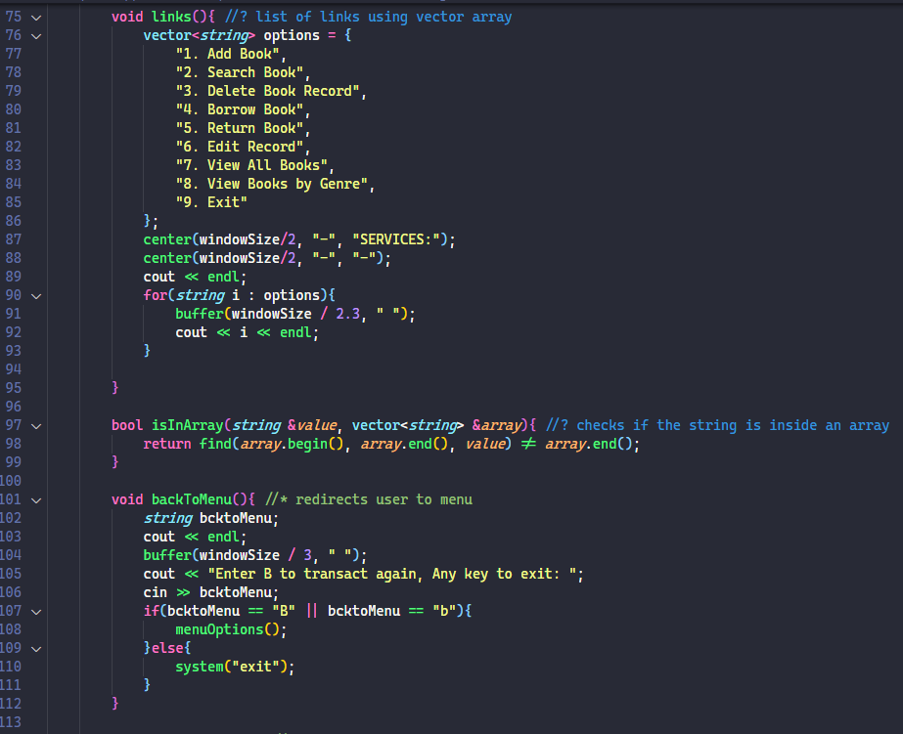

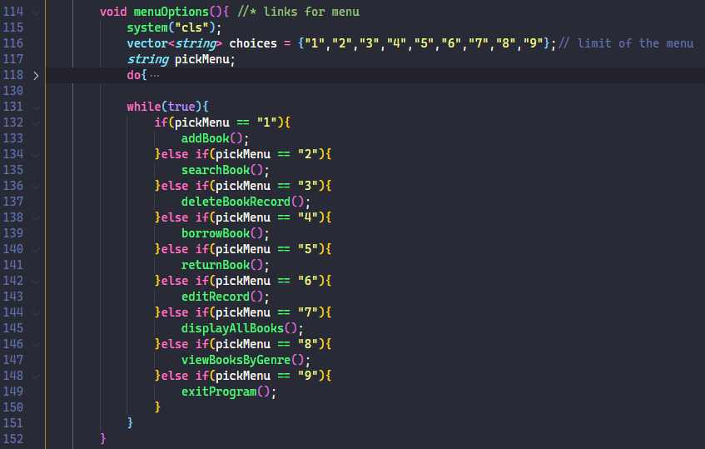

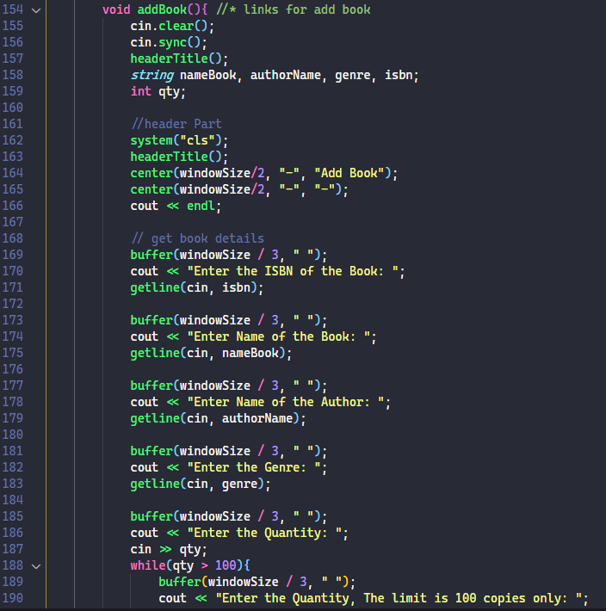

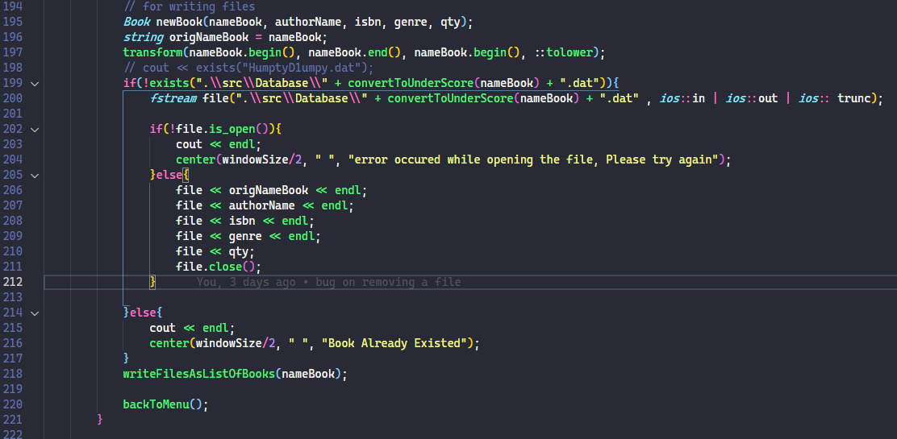

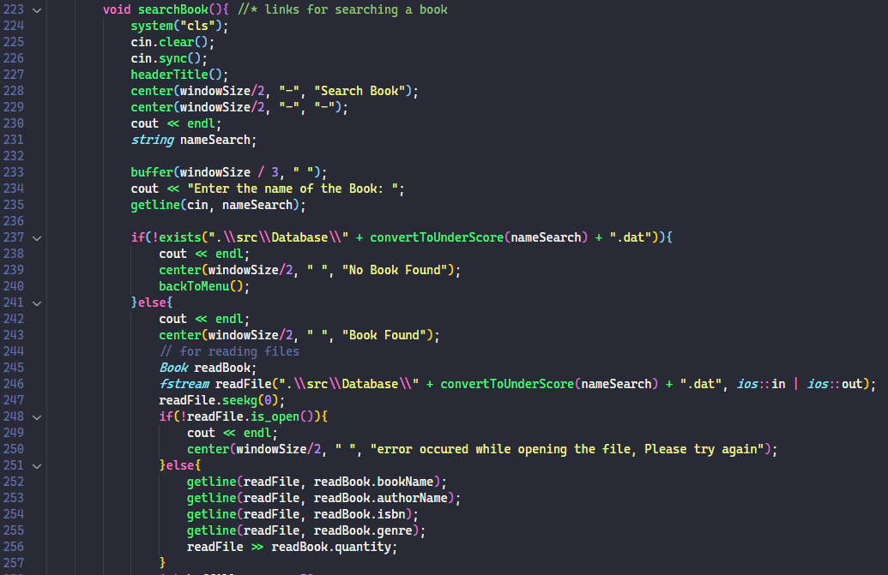

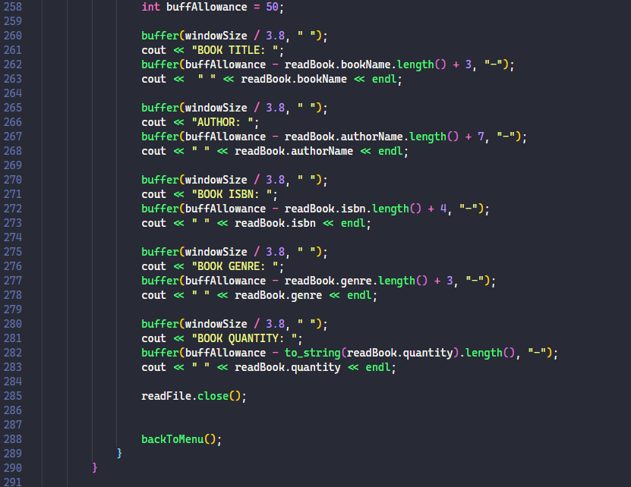

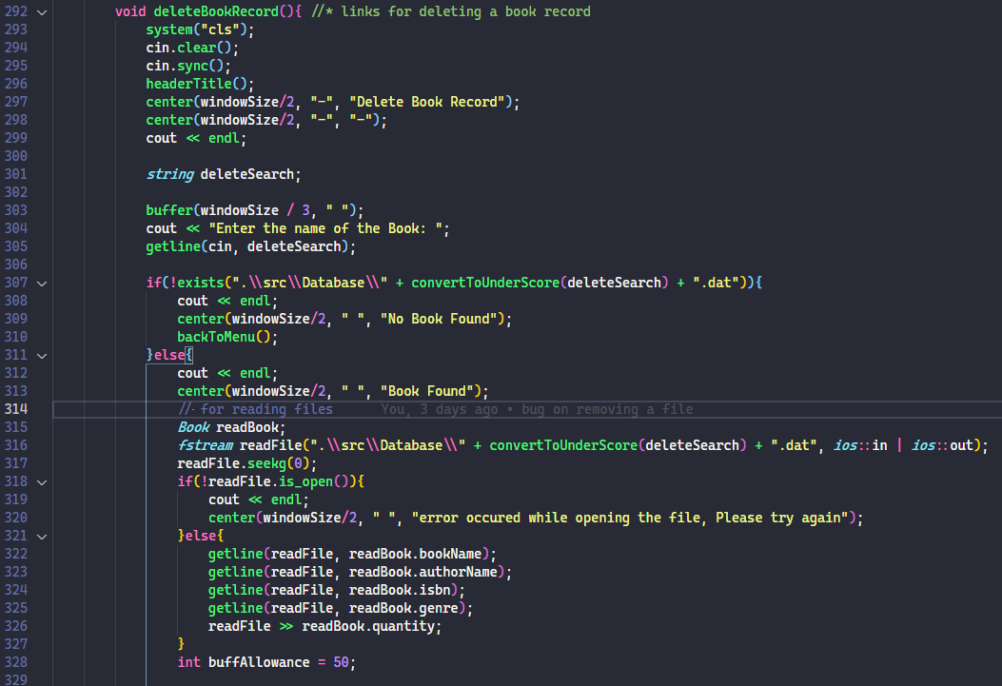

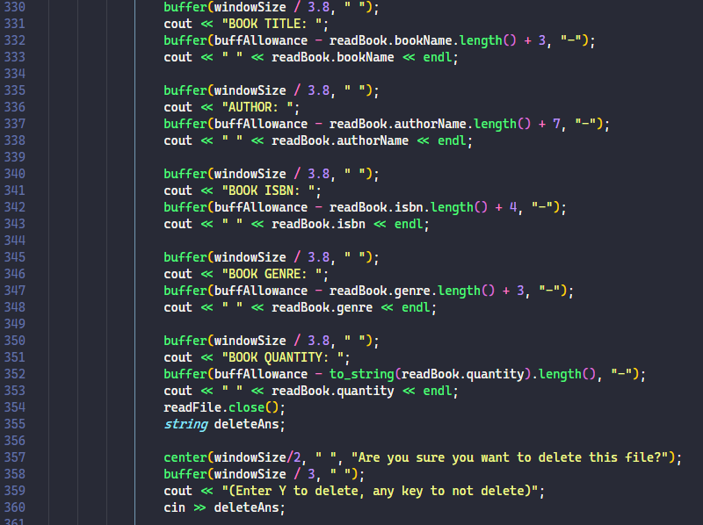

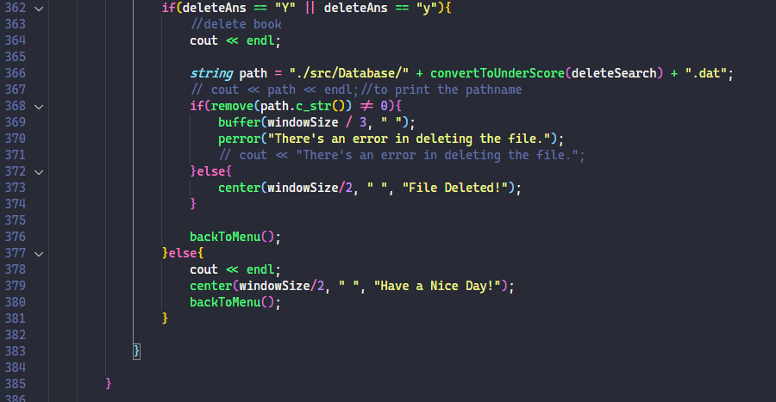

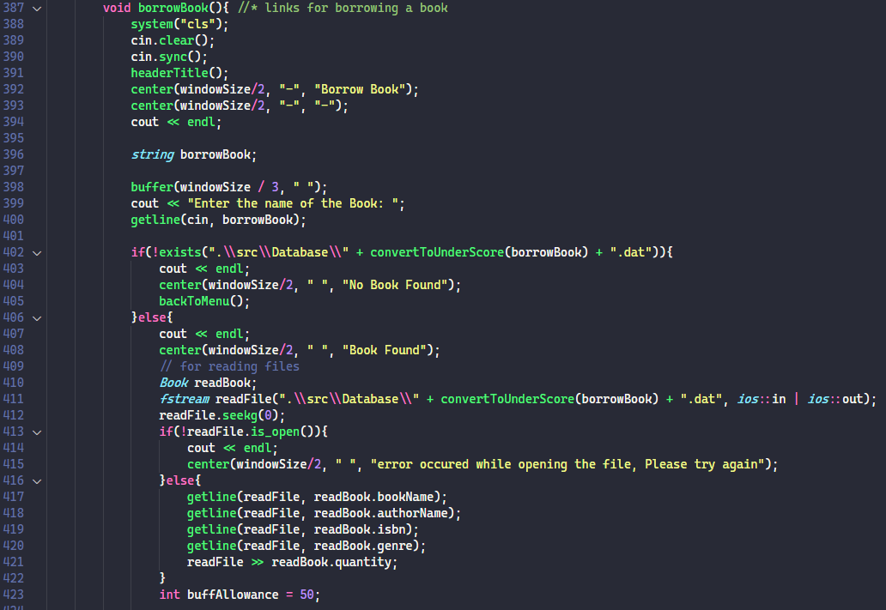

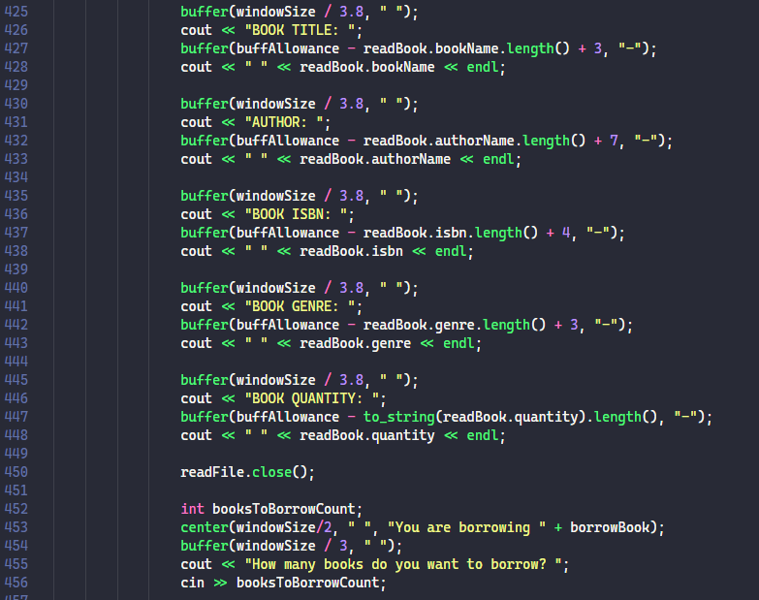

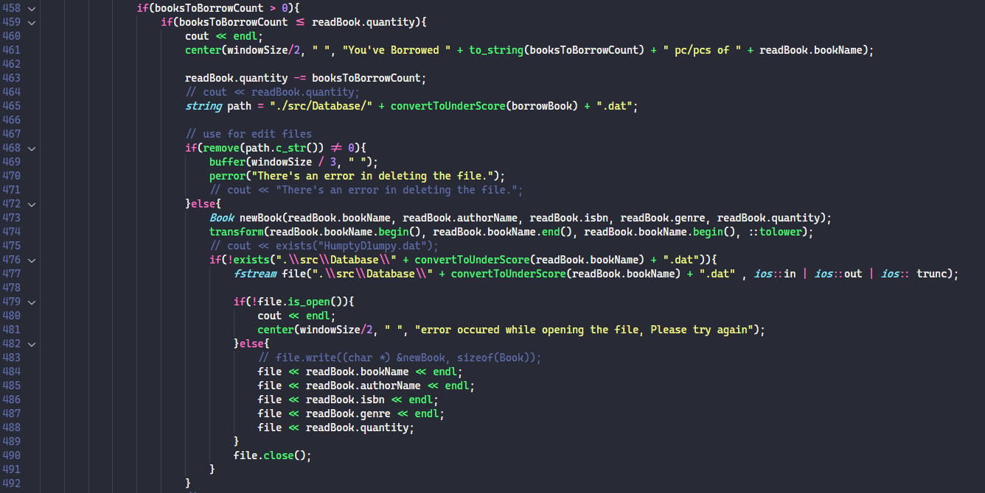

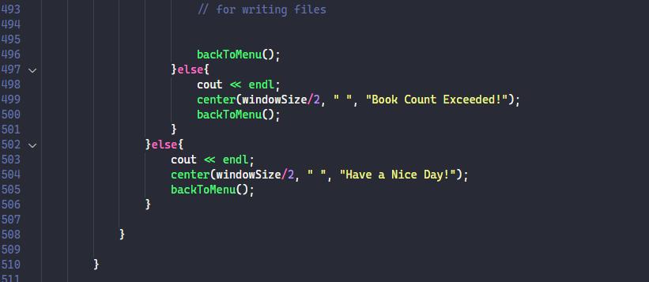

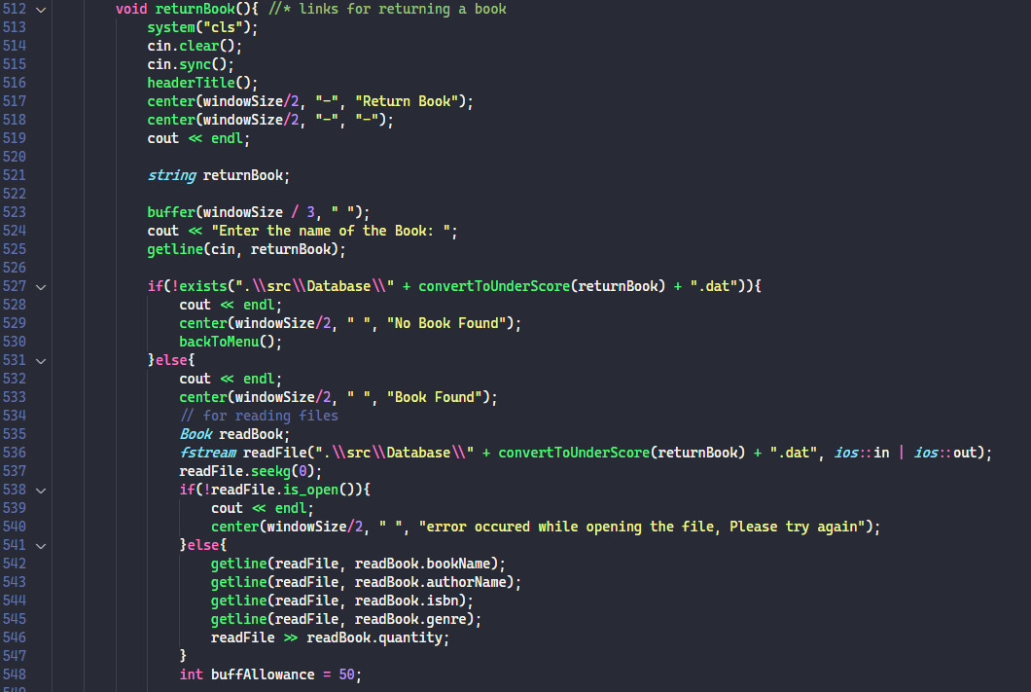

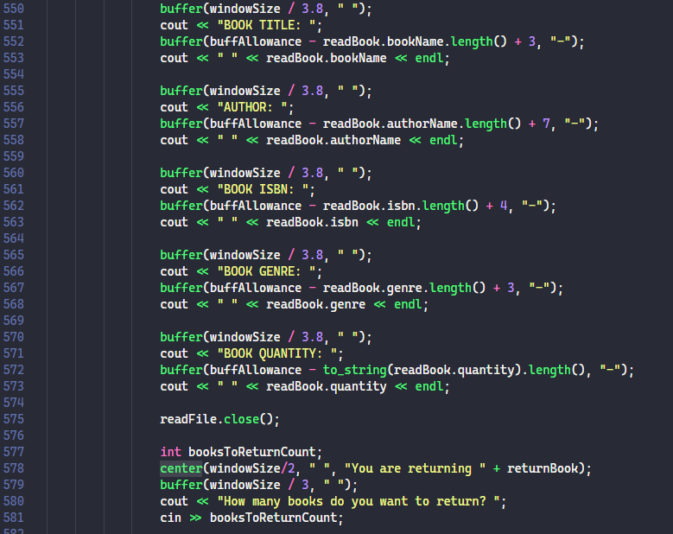

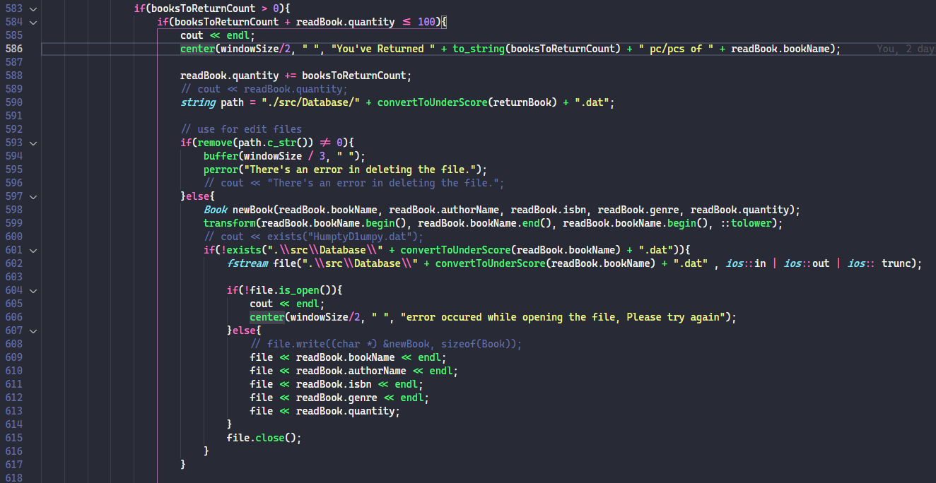

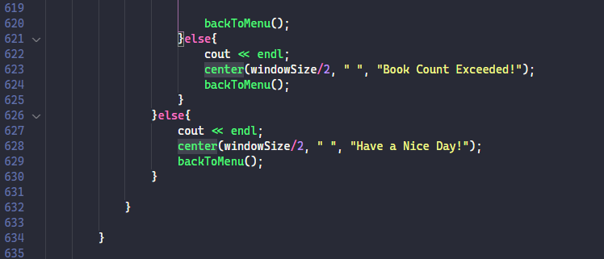

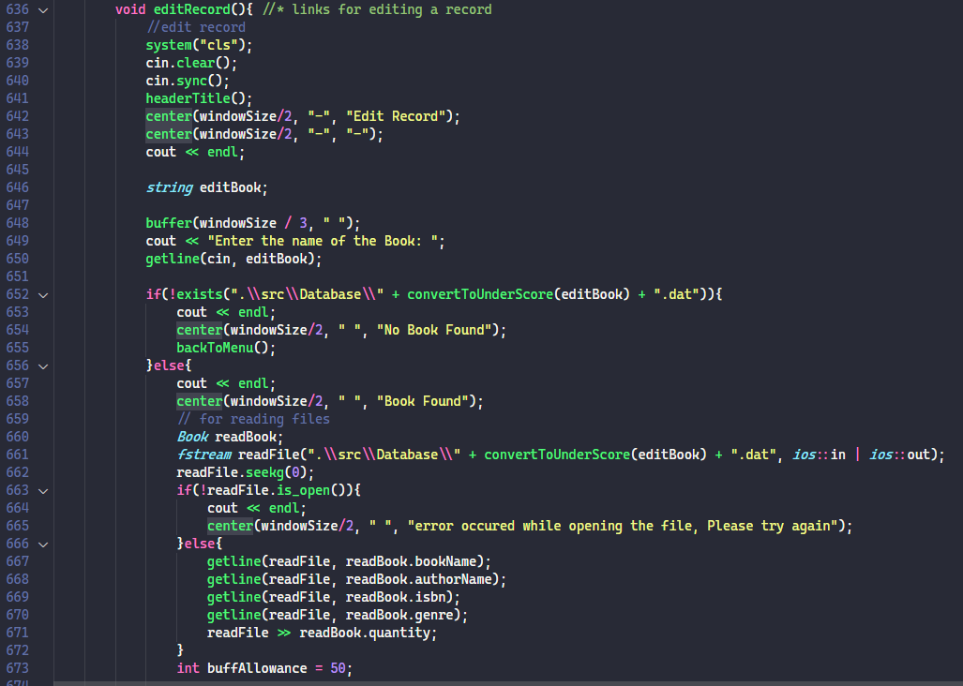

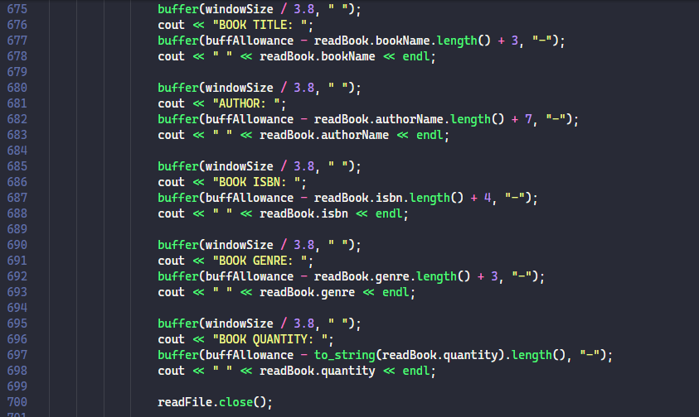

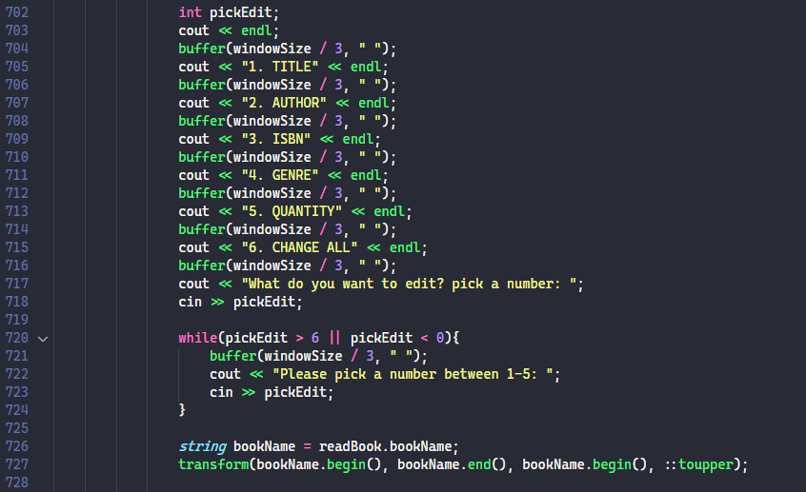

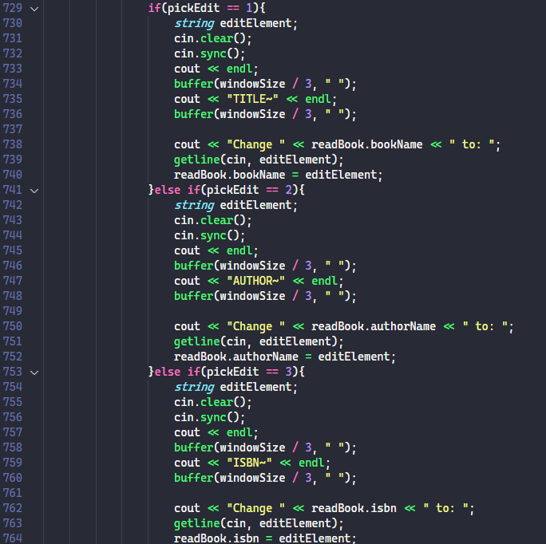



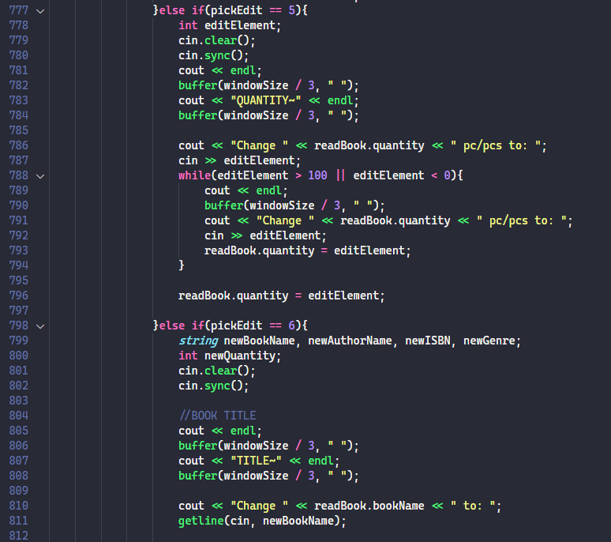

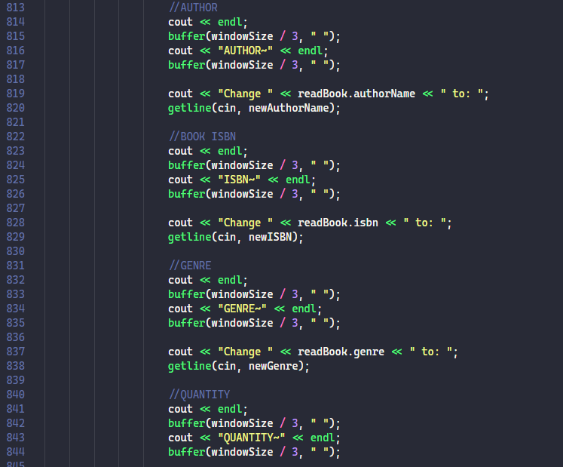

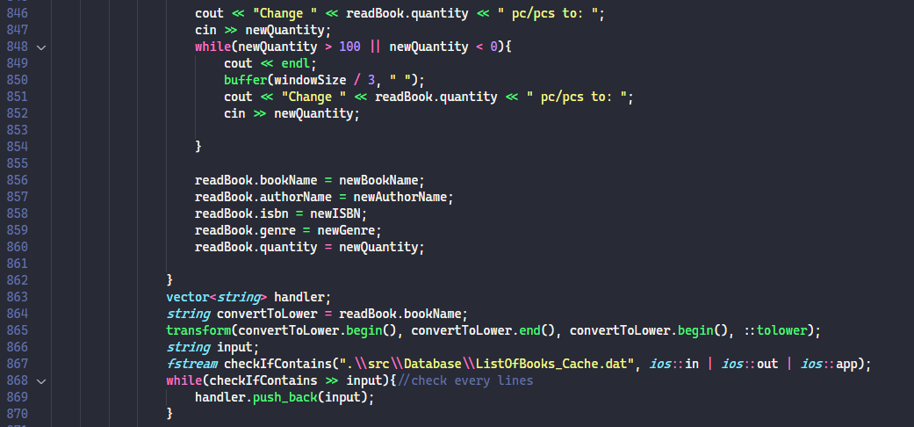

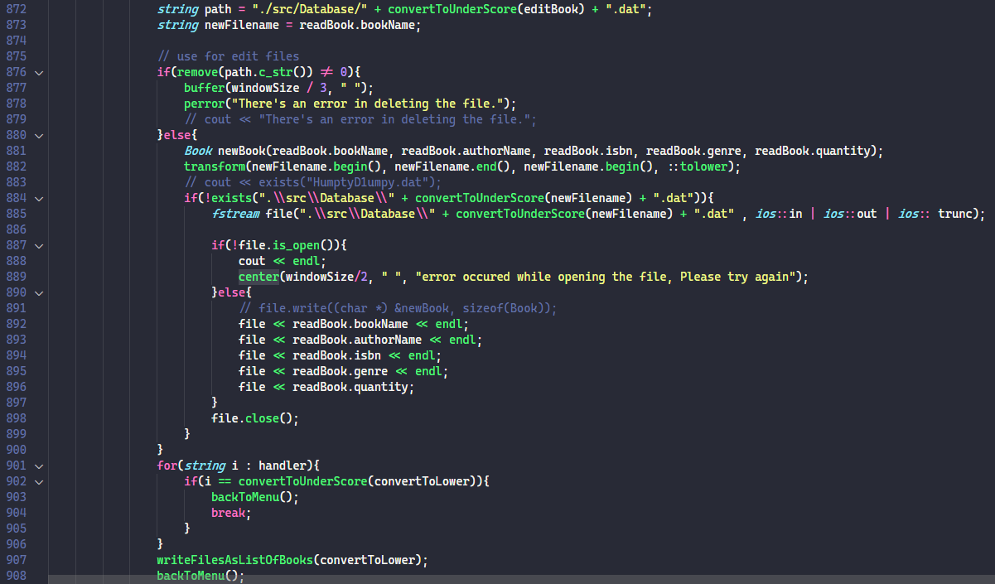

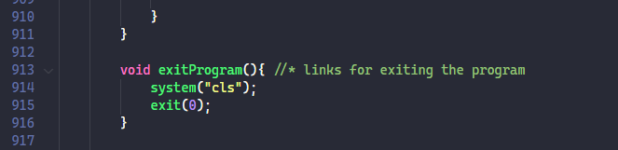

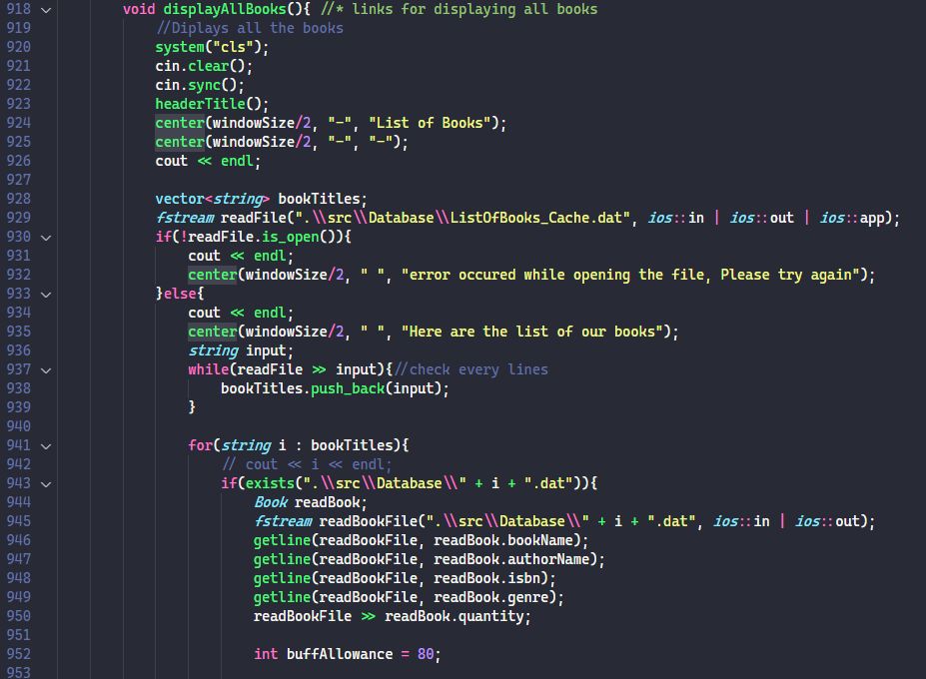

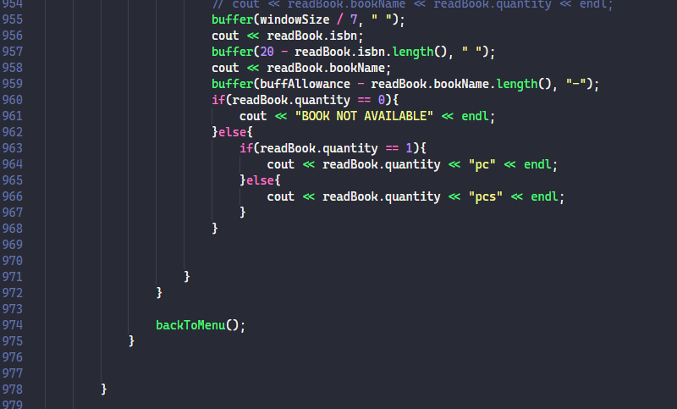

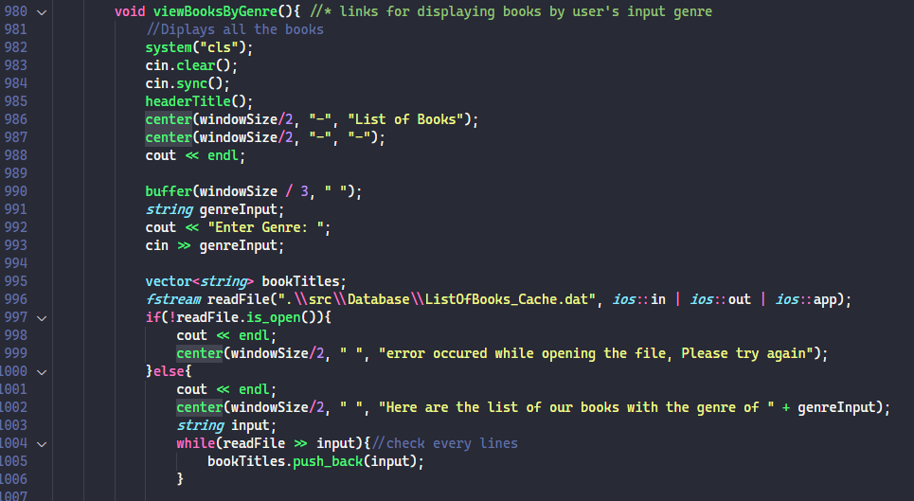

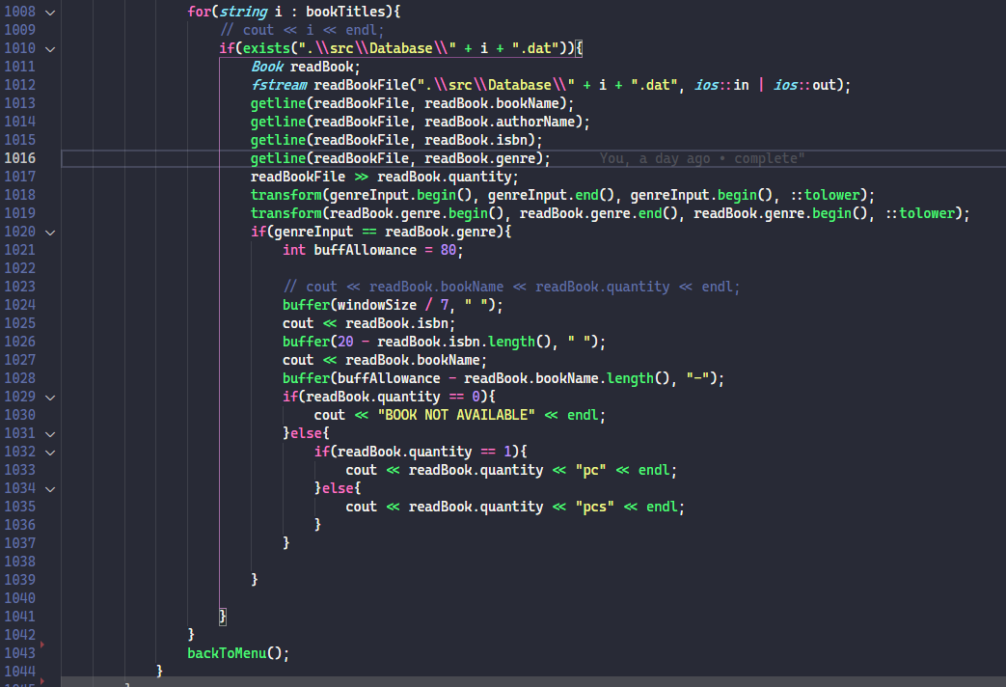

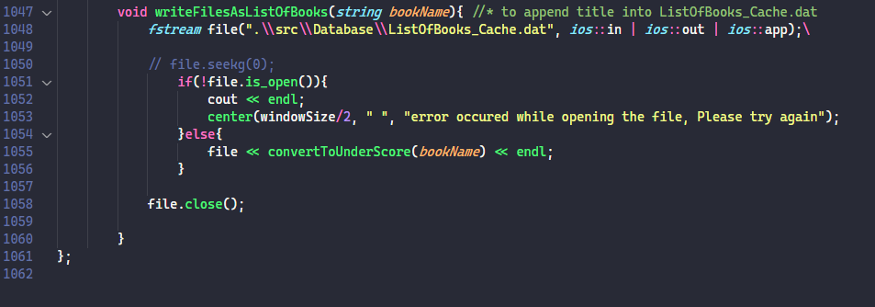

**~END OF CODE~**

.DAT files

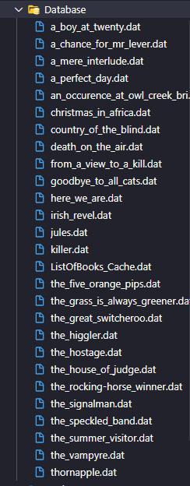

The book details entered by the user will automatically be stored inside the database folder, it will also automatically create a file for new books.

the ListOfBooks_Cache.dat file is simply a file to save all the books so that displaying it will be easier.

**ListOfBooks.cpp**

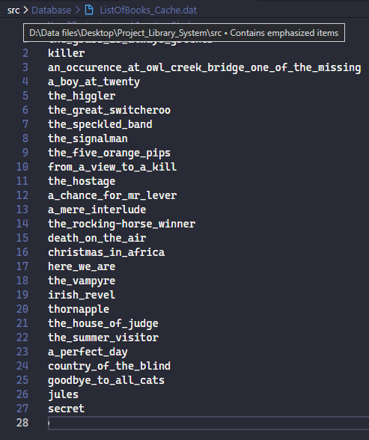

The filename of the file is automatically converted into lowercase and converts space with underscore to avoid conflicts in reading a file

These is the sample of the dat file and its format. The format is :

**BookTitle - string**

**Author Name - string**

**ISBN – string**

**Genre - string**

**Book Quantity - int**

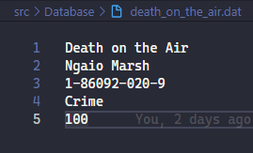

**OUTPUT**

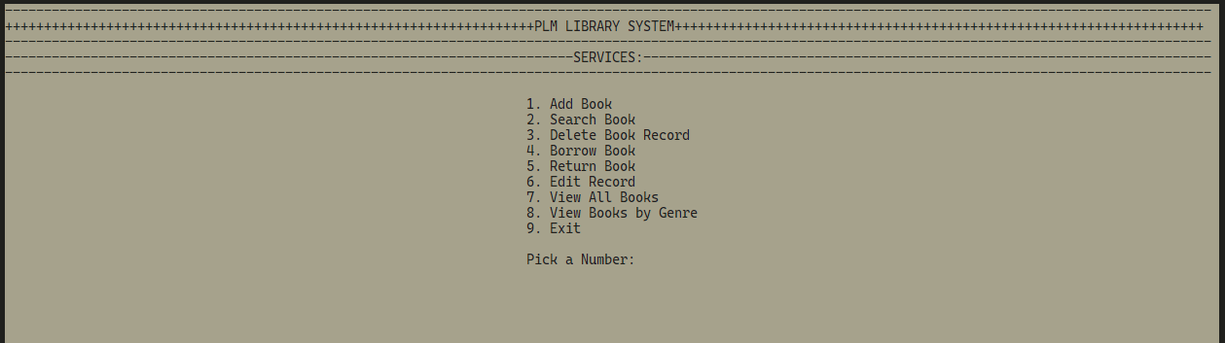**LANDING PAGE:**

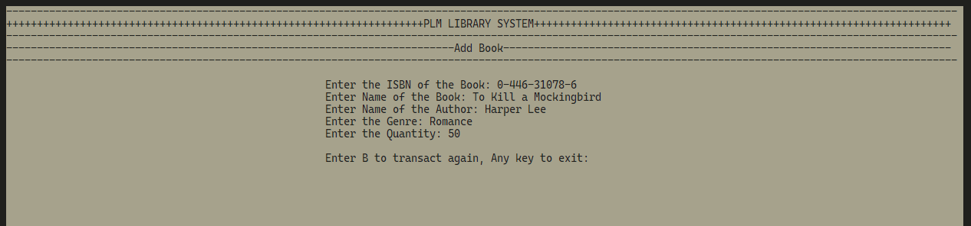**ADD BOOK PAGE**

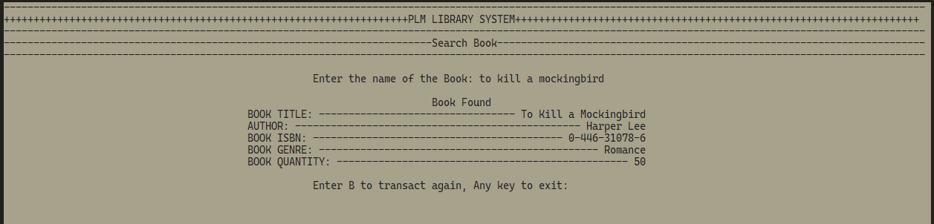**SEARCH BOOK PAGE**

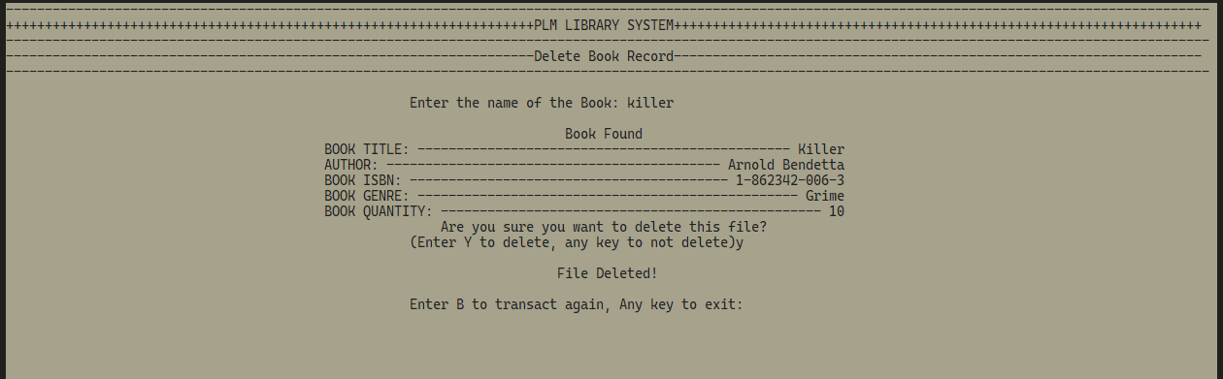**DELETE BOOK RECORD PAGE**

**BORROW BOOK PAGE**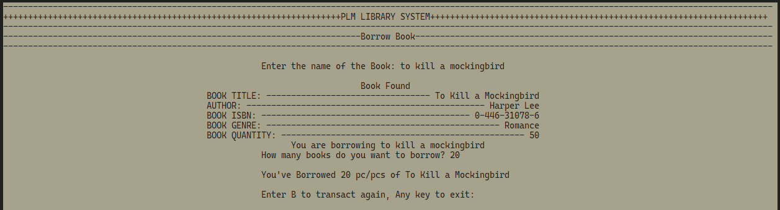

**RETURN BOOK PAGE**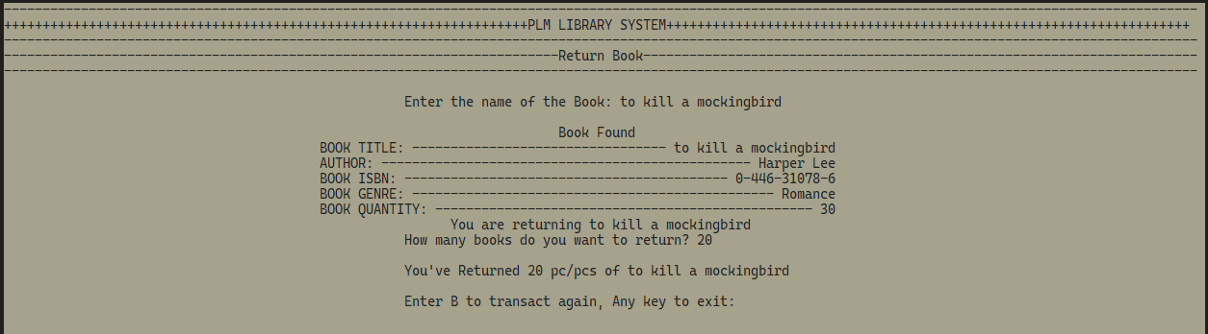

**EDIT RECORD PAGE**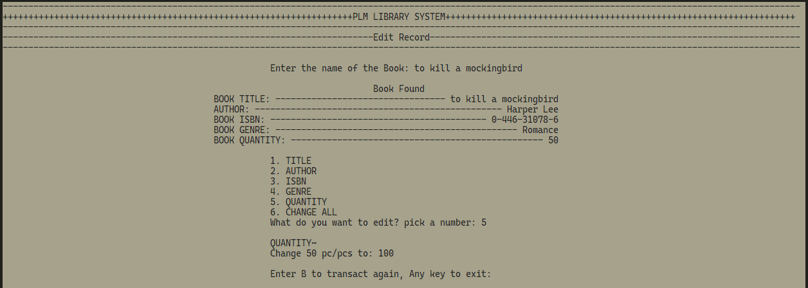

**LIST OF BOOKS/VIEW ALL BOOKS PAGE**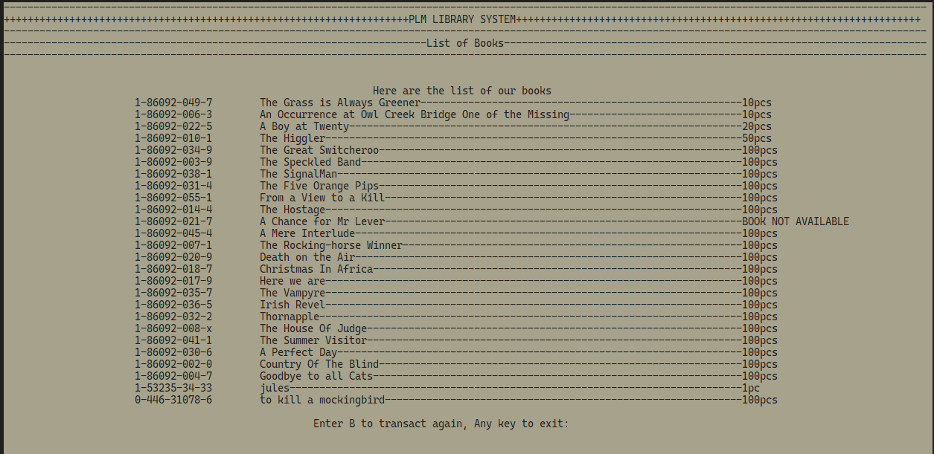

**VIEW BOOKS BY GENRE**